Usar:
https://nlcorp.app.netsuite.com/app/help/helpcenter.nl?fid=section_1535724805.html

They are trying to migrate www.abrimagery.com (Currently not SC) to the same domain but SC instance.
Issue with Live chat:
On Setup -> SuiteCommerce Advanced -> Google Tag Manager Editor:
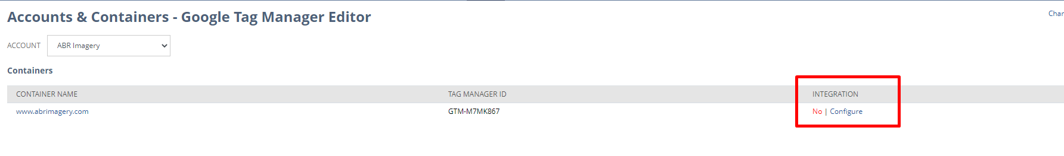
We can see it says no integration, we need to configure the domain, but when we go to configure:
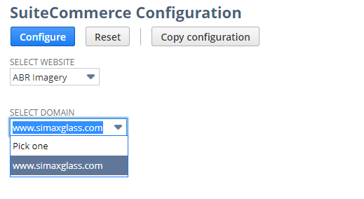
The domain is not there, since it’s their live domain

Pegar en Commerce -> Websites -> Configuration: choose the site -> Integrations -> Google tag manager, and fill up google tag manager. El error era con el espacio que tenia antes del id.

